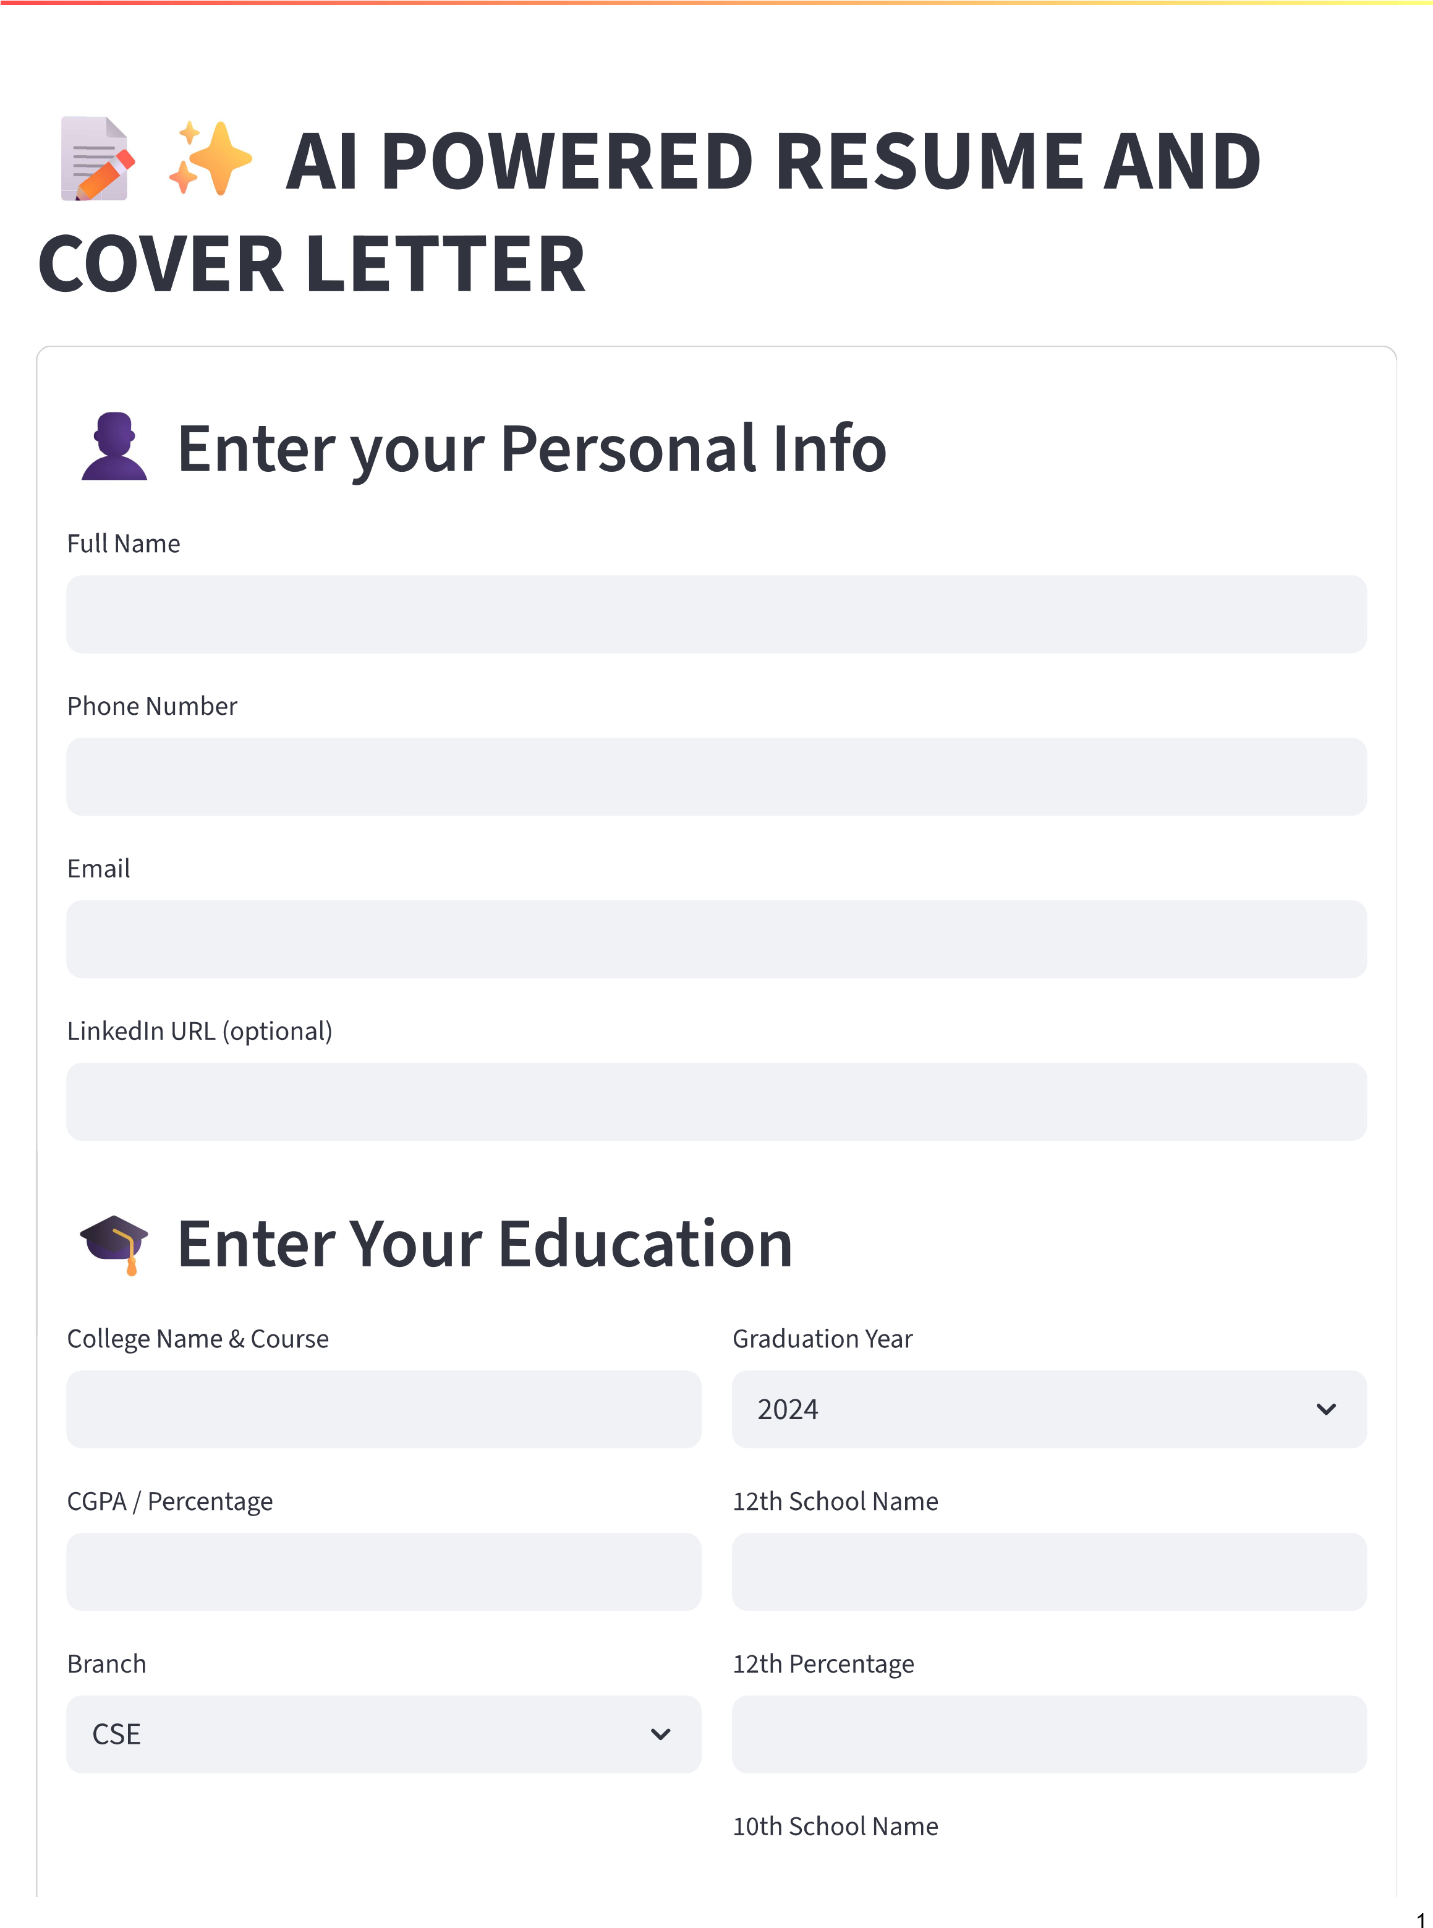

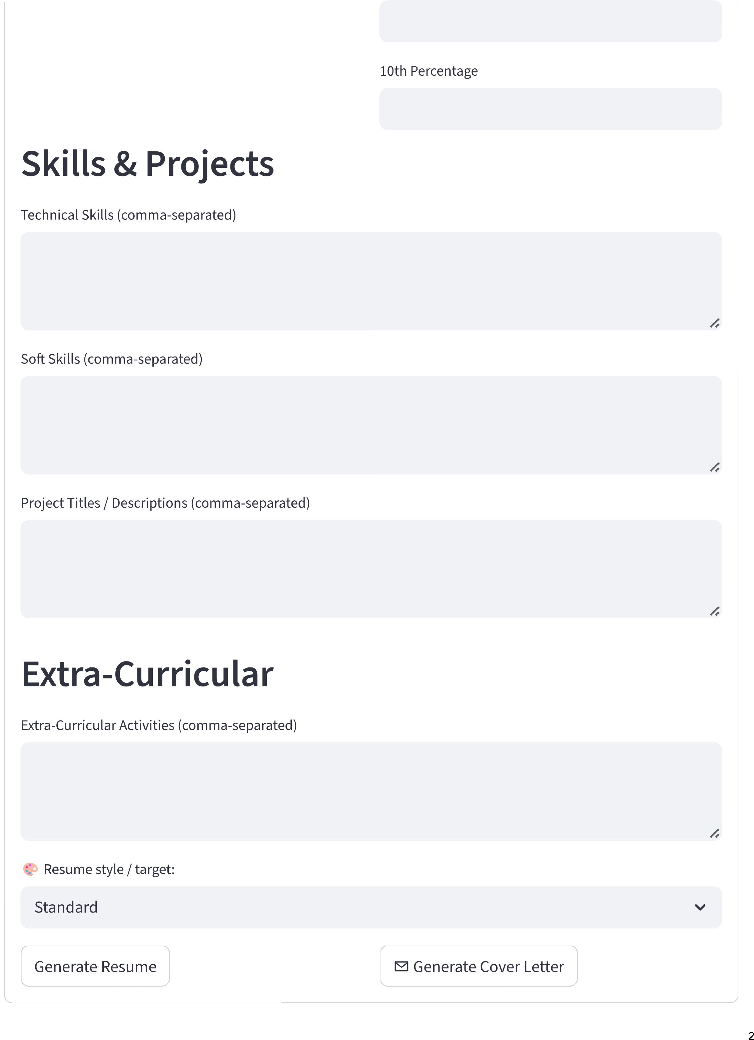

**Ajitabh Srivastava**

ajitabhsrivastava1304@gmail.com | 09451465723 |

**Profile Summary**

Myself Ajitabh Srivastava, a diligent and tech-savvy individual with a strong passion for innovation. With a

keen eye for detail and a flair for problem-solving, I leverage my skills in programming languages like

Python, Java, and C++ to deliver impactful solutions. Phone: 09451465723.

**Education**

United college of engineering (B.Tech CSE)

CGPA: 8.45

Year of completion: 2024

Achieved 80.1% from Bal bharti school in 12th

Secured 83.34% from Bal Bharti school in 10th

**Academic Projects**

**Project "Smart Home Automation"**

Utilized Python and Raspberry Pi to develop a smart home automation system, allowing users to control

lighting, temperature, and security systems remotely.

Improved energy efficiency by up to 20% through optimized scheduling and automation.

**Project "Machine Learning Chatbot"**

Designed and developed a machine learning-based chatbot using Python and TensorFlow, enabling

conversational interactions with users.

Achieved an accuracy of 92.5% in predicting user intent and responding accordingly.

**Technical Skills**

Programming languages: Python, Java, C++

Development frameworks: Django, Flask

Operating Systems: Windows, Linux

**Soft Skills**

Strong communication and teamwork skills through group projects and presentations

Proficient in MS Office Suite (Word, Excel, PowerPoint)

Quick learner with a strong attention to detail

**Extra-Curricular Activities**

Participated in various coding competitions, showcasing my problem-solving skills and adaptability.

Led a team of 5 students in developing a mobile app for tracking daily habits, resulting in a 25% increase in

user engagement.

*Generated by AI Resume Builder*

**Ajitabh Srivastava - Cover Letter**

09451465723

| ajitabhsrivastava1304@gmail.com |

Dear Hiring Manager,

I am thrilled to apply for the esteemed position at your organization, and I am confident that my

unique blend of academic excellence, technical expertise, and innovative thinking makes me an

ideal candidate. As a proud alumnus of United College of Engineering, where I earned my

Bachelor's degree in Computer Science and Engineering (CSE) with a commendable CGPA of 8.45,

I am well-equipped to tackle the challenges that come with this role.

Throughout my undergraduate journey, I had the privilege of working on various projects that

allowed me to hone my technical skills and develop a strong foundation in programming languages

like Java. One of the most memorable experiences was my final-year project, "Viva Voice," where I

designed and implemented an AI-powered chatbot that could engage in conversational dialogue

with users. This project not only helped me refine my coding abilities but also instilled in me a

passion for innovation and problem-solving.

As a detail-oriented and organized individual, I possess excellent communication skills, which

enable me to effectively collaborate with teammates and convey complex ideas in a clear and

concise manner. My strong academic record and impressive technical skills have equipped me with

the confidence to tackle complex problems and deliver high-quality results under tight deadlines.

In addition to my academic achievements, I am an avid learner who is always seeking new

opportunities to expand my skill set. I am well-versed in Java programming language and have a

solid understanding of computer science concepts. My proficiency in Java has enabled me to

develop robust software applications that are efficient, scalable, and user-friendly.

I would be thrilled to bring my skills and enthusiasm to your esteemed organization. You can reach

me at 09451465723 or ajitabhsrivastava1304@gmail.com for any further discussion or clarification.

My LinkedIn profile is also available for review. I am excited about the prospect of joining a dynamic

team like yours and contributing to its success.

Thank you for considering my application. I look forward to the opportunity to discuss how my skills

align with your organization's goals and objectives. Please feel free to contact me at your earliest

convenience.

Sincerely,

# Ajitabh Srivastava

*Generated by AI Resume Builder*